Rock—Paper—Scissors

The task: make the hub randomly display a rock, paper, or scissors.

Step 1: The Build
Let’s do the build.
Attach the LED matrix to the right side of the hub using two small black pins.  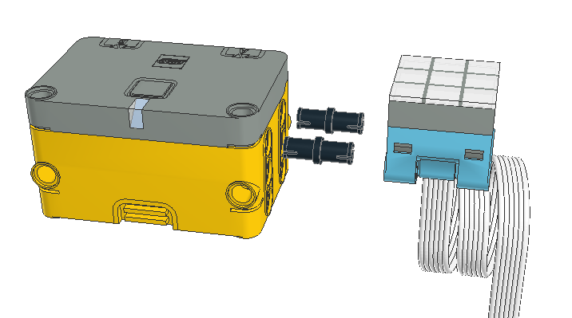 | Connect the LED matrix to port A of the hub.  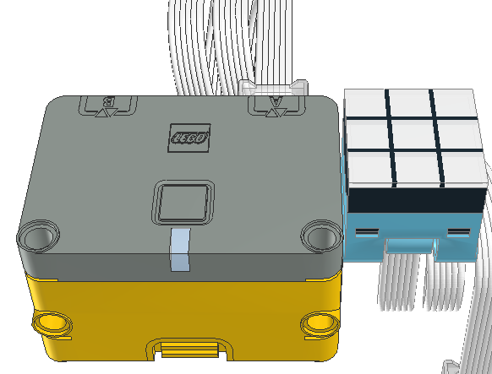

Step 2: Preparing to Program
To prepare for programming. Turn on the iPad, find the Spike App and start it.

When the app starts, select Spike Essentials on the left side of the window.
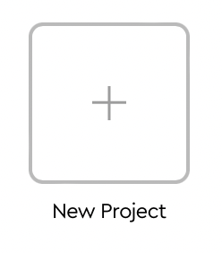
From the center portion the window, select the new project box.

Give the project a name, say “Rock-Paper-Scissors”.


Select word blocks.


Click on the create button to open the programming window.


Press the Connect button in upper left and follow instructions to connect BlueTooth to the hub.

Step 3. Programming
Break the problem down into steps:

- Begin the program with a tap block.
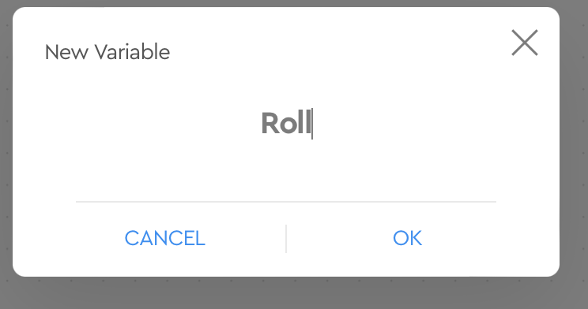

- Create a new variable and name it “Roll”.


- Set “Roll” to a random number between 1 and 3.

- Control the LED display for each of the following:
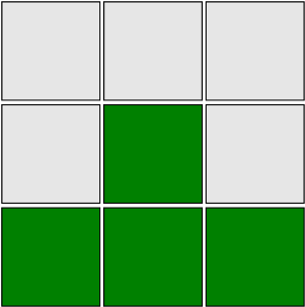  1. Rock |   2. Paper | 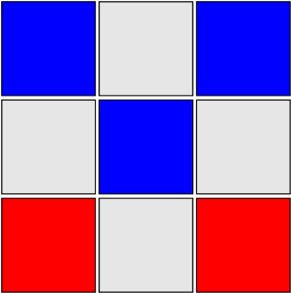  3. Scissors


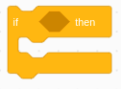
- select one of the three base on a roll variable


  - if ‘roll’ = 1, then display a rock

  - if ‘roll’ = 2, then display paper
  - if ‘roll’ = 3, then display scissors

- put it all together.
- Start the program by tapping on the hub.

Does it work as expected? No, can you fix it?

Can you improve it?

Can you add sounds for the sight impaired? Do your sounds make sense?

One Die

The task: Shake the hub to have it randomly show one side of a six sided die. (If you have more than one, it is two dice, three dice... If you have only one, it is one die. Yes, you only have the one.)

Step 1. The Build and programming preparatiion
See previous instructions for the build and preparation. In fact you can just add this program to the existing build and program.

Step 3. Programming
Break the problem down into steps:
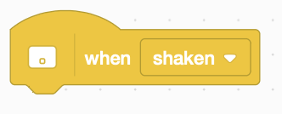
- Start with a shake block.

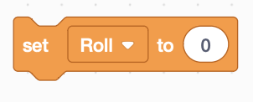

- Create a variable called “Roll” or use the previously created variable.
- Set “Roll” to a random number between 1 and 6.

- Change the LED based on the variable “Roll” from step 3.

  If roll = 1  then display 1 pip |   If roll = 2  then display 2 pips |   If roll = 3  then display 3 pips
  If roll = 4  then display 4 pips |   If roll = 5  then display 5 pips |   If roll = 6  then display 6 pips

Can you add sounds to count off the number of pips for the sight impaired? (Hint: the “coin” sound works well.)

Sounds that are too long can be stopped after a delay.

